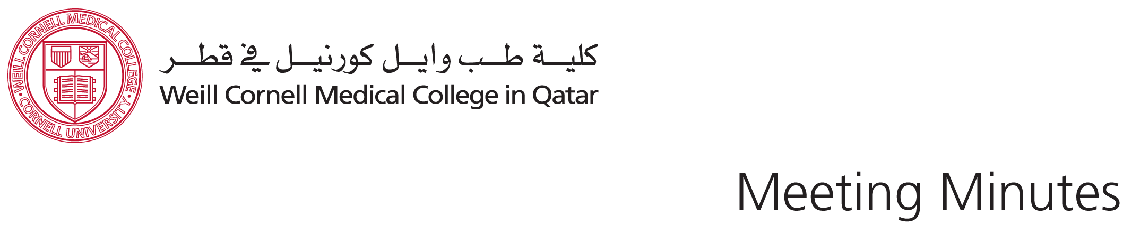

**Emerging Technologies Symposium Committee Meeting**

**Thursday, October 8, 2015**

**Present:**

Sally, Alice, Wumi, Mike, Ross, Reya

**Apologies**:

Ellen, Paul, Carol

**Recorder:** Reya

1. **Approval of minutes from the previous meeting:**

The minutes from September 29, 2015 meeting were approved.

1. **Website progress**: Sa’ad informed Sally that the Symposium Website would be ready by the end of next week. We still need to get Ellen’s approval for the content as well as the Communication department for using the new WCM-Q Logo and branding.
2. **New email list-group:** Mike informed the committee that a new email address was created [delibevent@qatar-med.cornell.edu](mailto:delibevent@qatar-med.cornell.edu). Sally, Paul, Reya and Ross will receive copies of emails sent to this email address and will use it to send out emails regarding the Symposium.
3. **Registration Software**: Mike contacted ITS to inquire about the Registration Software they developed in-house. Sally and Sa’ad also attended training by Xenegrade. After reviewing both products, it was decided to keep on using LibCal. Mike said that it can be customized to include a drop down menu from which participants can choose to register for specific sessions.
4. **Badges:** Wumi got a pricelist for Clip badges with the transparent ID cover. 300 plastic cover clip badges with white label for QR4,500.

The badges can be customized: 50 badges for speakers/ 20 keynote/ 30 organizers/ 20 sponsors.

Wumi will also ask for a sample ribbon. She will also check at Jarir for cheap red lanyards.

1. **Venue update:** Grand Heritage is confirmed as the location to host the symposium for 2 days only as the workshops will take place at Georgetown University and Texas A&M.

The terrace area can be used with no extra charge. Ross suggested we go and check how the place can be arranged for our event.

Sally suggested we check with FM to arrange cocktail reception over Georgetown University and Texas A&M during the workshops.

1. **Speakers:** Ross and Wumi are meeting with Nicole for lunch today to discuss in details her session.

Ross did not hear back from Hanif yet. He will follow up with him and report back.

1. Sally did not hear back from Dr. Mary Sengati Zimba or Dr. Judith Mavodas from Abu Dhabi. She will check with Linda for follow-up.
2. Sally did not hear back from Robert Laws. She will ask Sa’ad to follow-up with him.
3. Paul met with Yasser. The workshop will be held at Texas A&M.
4. Sally reported that so far, Mirko, Pamela and Barbara have submitted their bios and abstracts.
5. Mike and Alice reported that they did not hear back from vendors. Ellen will be going to Abu Dhabi and she will meet with Gale there.
6. **Other:** There was a discussion whether DeLib people should attend Roundtable and take note of discussions. However, this might be uncomfortable for people participating in it. It was decided that DeLib people would attend the Roundtable, and participate in discussion and write a brief reflection afterwards.
7. Reya suggested having transportation from/to Education City/Grand Heritage Hotel for QF people. She will inquire about the cost and availability from FM.